**Apply Your Knowledge**

In step 8, you applied a float property to the aside element. Describe the purpose of the float property and discuss another way to achieve similar results.

The float property floats the aside element, in this instance, to the right of the main element. If the float property is removed, it appears behind the main element. You could use an overflow property with a value of auto to achieve similar results.

**Extend Your Knowledge**

In this exercise, you discovered other ways to create a column layout. Use your browser to research grid layouts. Include a description of your findings.

Grid layouts are rows and columns used in webpage design to aid a web designer in the placement of HTML elements and content.

Source: http://gridbyexample.com/

**Analyze, Correct, and Improve**

Identify another way to modify the HTML structure of the page using the div elements instead of the HTML5 semantic elements and provide an example.

An id could be added to each div element to uniquely identify the purpose of each element. For example:

<div id="header">

<div id="nav">

<div id="main">

<div id="section">

<div id="article">

<div id="aside">

**Lab 1**

In this assignment, you created several HTML5 semantic elements. Research the time semantic element, identify its use, and then discuss its attribute and the different ways in which time can be displayed.

Use the time element to insert a time easily read by people, as opposed to machine code.

The time element has a datetime attribute, which is used to display the current date/time in a number of formats, such as September 2016, 25 September 2016, 25 September.

**Lab 2**

In step 12, you created a style rule for a figcaption element. Discuss at least three different properties you would use to improve the appearance of this element.

The figcaption element could be improved by applying the following three properties:

1. Add a text-shadow
2. Apply a background color
3. Apply a font style or font weight

**Lab 3**

In step 3, you applied a background image to the body element so that it would consume the entire webpage. Use your browser to research the background-size property and discuss other areas where this property could be applied.

The background-size property is quite popular with today’s websites. It can be applied to any element desired.

**Your Turn 1**

Use your browser to research the HTML5 details and summary semantic elements. Discuss where you could integrate these elements with your site and why.

The details element can show or display additional content. The summary element is used to provide a short summary regarding the details element. I could integrate the details element on my work experience page to show or hide my work experience. The only drawback is that this element is not supported by IE or FireFox.

**Your Turn 2**

In step 5d, you added a style rule for the aside element. Use your browser to research different ideas for styling the aside element. Provide a screen shot of the designs you found and a link to each resource.

Aside style example #1

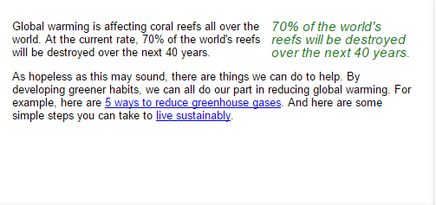

Source: http://www.quackit.com/html_5/tags/html_aside_tag.cfm

Aside style example #2

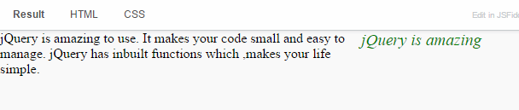

Source: http://20fingers2brains.blogspot.com/2013/02/aside-tag-in-html5-with-example.html

**Your Turn 3**

Each person in the group should research different layout design strategies for the website and present a proposed wireframe to the group for a discussion. In the discussion, the group should review each wireframe and make a decision to apply the most popular design. Organize your group’s findings as requested by your instructor.

Proposed Layout strategy:

footer

article

article

article

banner image

nav

header